Tinggal
Answer this question -
Activity 1) Practise asking and answering this question. Share this response with your family.
Kamu tinggal di mana? (Where do you live?)
Saya tinggal di ___________ (suburb only) (I live in …)
Activity 2) Choose 3 well known characters or people.
Imagine that you ask them where they live “Kamu tinggal di mana?” then write their answer to the question “Saya tinggal di ______”. You will see the names of some countries on the chart.
Here is an example -
Nama
Ed Sheeran | “Kamu tinggal di mana?” | “Saya tinggal di  Inggris.” (I live in England)
1. | “Kamu tinggal di mana?”
2. | “Kamu tinggal di mana?”
3. | “Kamu tinggal di mana?”

Negara – Negara
Countries
Greece – Yunani  Singapore - Singapura  New Zealand - Selandia Baru  Canada - Kanada  China – Cina  Scotland - Skotlandia  Egypt - Mesir  England - Inggris  America - Amerika  Turkey – Turki  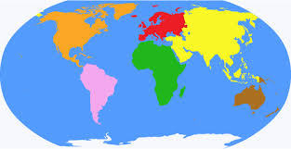 | Australia - Australi  Germany - Jerman  Holland - Belanda  Ireland - Irlandia  Italy - Italia  Japan - Jepang  Mexico - Meksiko  France - Perancis  Philipines - Filipina  South Africa - Afrika Selatan  Spain - Spanyol

Activity 3) Rumah-rumah di Indonesia (Houses in Indonesia).
Compare these two types of houses in Indonesia. List some of the features of each house. Illustrate these houses.
Komodo island Lake Toba
