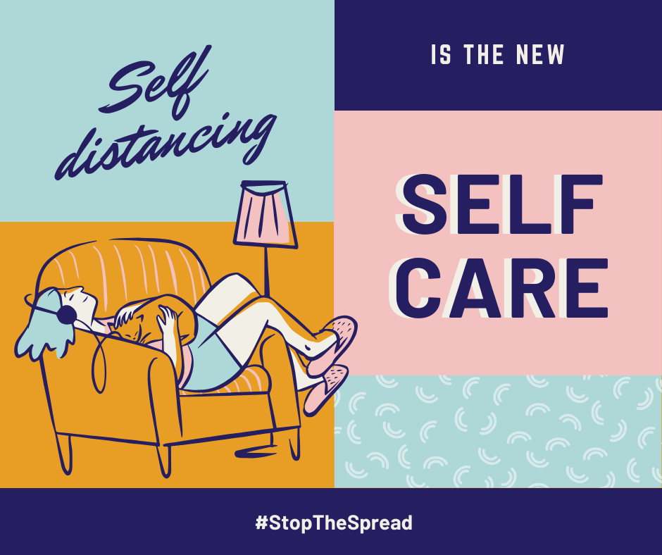

SELF-CARE: PUT YOUR OWN OXYGEN MASK ON, THEN HELP OTHERS

If you’ve travelled on a plane, you’ll know the flight attendant’s safety briefing: brace positions, emergency exits, and remember to put on your own oxygen mask first. The reason we’re told this is because you can’t help others if you’re running low on oxygen yourself. In the same way, we can’t take care of those around us if we aren’t taking care of ourselves. Self-care is very important, particularly in times like these.

We have a couple of self-care resources for you to check out:
- Have you ever tried Self-care Bingo? (There are two versions – the original and a blank version so you can make your own bingo sheets!)
- Superfriend ‘Looking after you: simple strategies for busy times’
- This Beyond Blue article talks about the importance of self-care, and particularly a balanced approach to the “treat yo-self” mindset

Something we really want to highlight is that switching off and just doing nothing sometimes is also part of self-care. Taking a break, taking some time by yourself, and being okay with not always being productive during isolation is more than okay.
A lot of people are seeing this time as an opportunity to “be productive”, to learn new skills, to enhance themselves, to do things around the home that they have been meaning to do. This can be good but can also become a guilt trap when the reality doesn’t meet the expectations. Remember, we are in unchartered territory, we are all doing our best, and we need to go easy on ourselves. Practising self-compassion is extremely important – switch around that old saying ‘treat yourself as you would treat others’
Many of us are spending a LOT of time with family, which is wonderful. But we also need time for ourselves – so go for a walk, run, bike ride, do an exercise video in your loungeroom, switch off and listen to music, enjoy some fresh air, take a bath (and lock the door!) or just sit somewhere on your own and breathe.
Taking deliberate downtime is more important now than ever. This might seem impossible sometimes for those of us working from home (and having kids schooling at home on top of that!). A little bit of solo time out is for the benefit of not only you but the ‘greater good’. It will benefit our families, our friends and our community. Don’t let feelings of guilt stop you from taking the time you need.
Stuck for self-care ideas? Why not try these? (they will also help you check off a square in Self-Care Bingo!):
- Try a new recipe
- Live Lighter have pulled together some tasty and easy meals using pantry staples we might have on hand right now.

- Take steps to tame negative thoughts and practice deep breathing
  - Smiling Mind – is a free mindfulness meditation app to help you look after your mental health and manage stress and daily challenges.
  - Headspace – is offering a free ‘Weathering the Storm’ program with a curated list of calming meditations, help with sleep, and at-home movement exercises.

- Play an online game or board game
- Have you heard of boardgamearena.com? You can play heaps of your favourite board games online for free!

- Read a book
- goodreads.com is a great way to find your next book, review your favourite reads and connect with other bookworms.

What are your self-care strategies? We would love to hear them and to share them! Please comment below or send us a line at healthycommunities@bch.org.au

