DRYSDALE YOUTH FESTIVAL
FRI NOV 29- SAT NOV 30
There will be a range of activities running at various locations in Drysdale-FREE EVENT
Skate Ramps Live Bands Leadership Workshops First Aid course Movie Screening Tennis Dance Musical Theatre Art Exhibition
Follow the links below to view a schedule and book in.
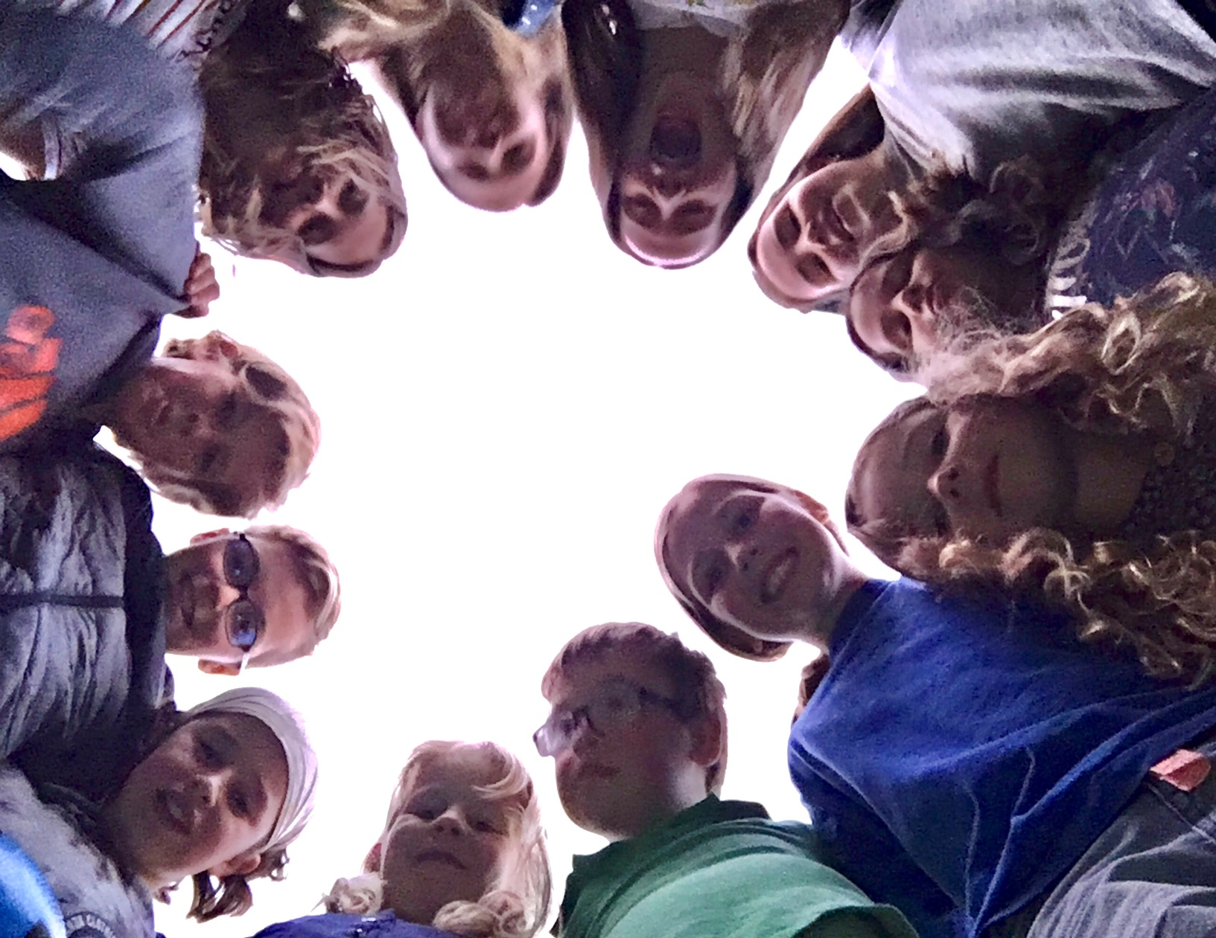
eventbrite.com.au/o/raelene-newton-drysdaleyouthfestivalgmailcom-8223823599

https://www.facebook.com/events/474043053214310/

